## Persistence with JPA

General part

* Describe how you have handled persistence in the last three semesters.
* The considerations should include all relevant layers. File IO, Relational Databases, local storage and cookies in browsers.
* Explain the Pros & Cons in using an Object Relational Mapping Framework
* Elaborate on some of the problems a ORM tries to solve
* Explain the basic “components” involved when using Java’s JPA

Practical part

The model below is an initial model for a system than can handle *Users* and *Projects* assigned to *Users* (contributors to the project). A project can have a number of assigned *Tasks*.

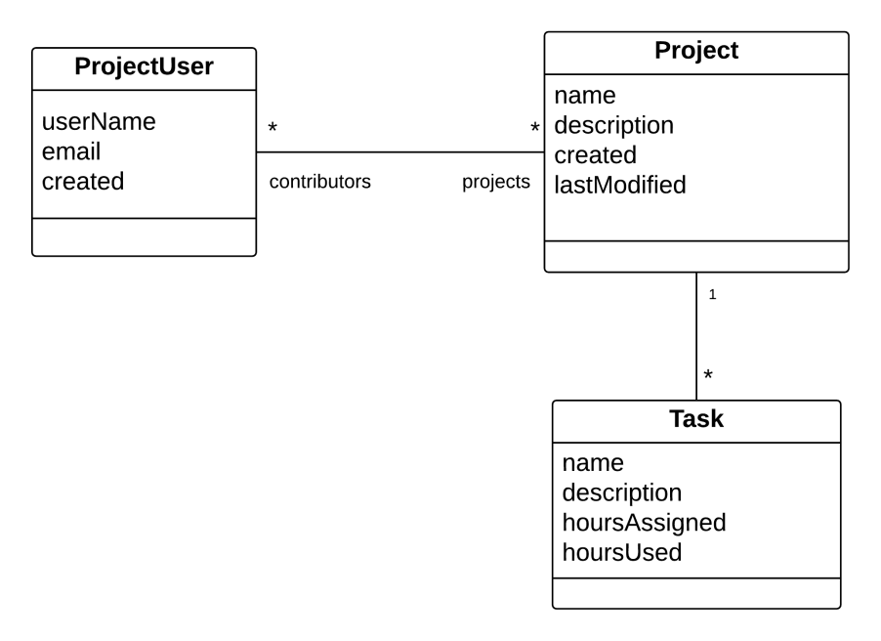

1. Examine and understand the diagram. Use Object Relational Mapping (using JPA) to implement the OO classes and the corresponding Database Tables.
2. Create a façade class and implement as many of the methods below as you have time for (not necessarily in the order given):

* Create user
* Find user
* Get all users
* Create project
* Assign user to project
* Find project
* CreateTaskAndAssignToProject
* Etc.